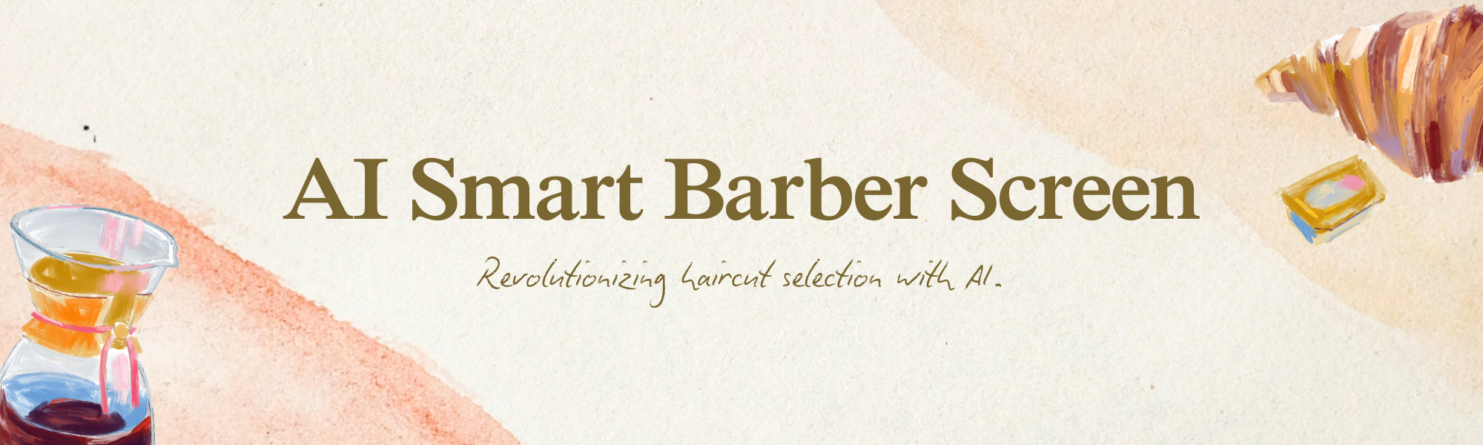
Project Overview: AI Smart Barber Screen
Category:
- Retail Technology
- Artificial Intelligence
- Personalization
Target Market:
- Barbershops
- Salon Chains
- Male Grooming Industry
Core Idea:
An in-store AI system that analyzes customer facial features and offers personalized haircut recommendations in real-time.
Objectives:
- Enhance customer satisfaction and engagement.
- Improve barbershop service offerings with innovative technology.
- Drive revenue growth by enabling informed haircut choices.
- Establish a competitive edge through technological differentiation.
Existing Market Issues:
- Uncertainty in Haircut Selection:
  - Customers frequently have difficulty choosing a haircut that complements their face shape and personal style.
- Communication Gap:
  - Misunderstandings can occur between barbers and customers regarding desired outcomes.
- Limited Inspiration:
  - Traditional haircut catalogs may be outdated and fail to provide personalized suggestions.
- Inefficiency:
  - The consultation process can be lengthy and may not always lead to optimal haircut choices.
Market Gap:
There is a noticeable absence of readily available, AI-driven solutions in the barbershop setting to assist in haircut selection and enhance the customer experience, as current methods often rely on manual consultations and subjective opinions.
The Idea:
Develop and implement an AI Smart Barber Screen—an interactive display unit within a barbershop that utilizes facial recognition and AI algorithms to analyze a customer’s facial features and recommend appropriate haircut styles in real-time.
Innovation Factor:
- AI-Powered Personalization:
  - Utilizes AI to deliver data-driven, personalized haircut suggestions.
- Real-time Simulation:
  - Enables customers to visualize different haircuts before committing to a style.
- Enhanced Customer Engagement:
  - Fosters a more interactive and engaging atmosphere in the barbershop.
- Data-Driven Insights:
  - Provides barbershops with valuable insights into customer preferences and trends.
Hardware Setup:
- High-Resolution Display Screen:
  - A large, touch-sensitive display for clear visualization and user interaction.
- High-Definition Camera:
  - An integrated camera for precise facial scanning and analysis.
- Powerful Processing Unit:
  - A dedicated processing unit to run AI algorithms and render simulations.
- Secure Enclosure:
  - A robust housing to protect the hardware components.
Software Setup:
- Facial Recognition Algorithm:
  - An AI algorithm designed to accurately identify and analyze facial features.
- Haircut Recommendation Engine:
  - An AI engine that suggests suitable haircuts based on facial analysis and a pre-loaded haircut database.
- Real-time Simulation Software:
  - Software that overlays simulated haircuts onto the customer's image in real-time.
- User Interface (UI):
  - An intuitive and user-friendly interface for easy navigation.
Execution Flow:
- Customer Arrival:
  - The customer enters the barbershop and approaches the AI Smart Barber Screen.
- Facial Scan:
  - The system prompts the customer to position themselves in front of the screen for a facial scan.
- Analysis & Recommendation:
  - The AI algorithm analyzes the customer's facial features and generates personalized haircut recommendations.
- Simulation:
  - The customer browses recommended haircuts and visualizes how they would look using the real-time simulation feature.
- Selection & Confirmation:
  - The customer selects their desired haircut and confirms their choice.
- Barber Execution:
  - The barber receives the selected haircut style from the customer and proceeds with the haircut.
- Feedback & Data Collection:
  - The system gathers customer feedback on their experience and compiles data for future enhancements and trend analysis.
The AI Smart Barber Screen presents an innovative solution to prevalent issues in the barbershop industry. By utilizing AI-driven personalization and real-time simulation, this system improves the customer experience, boosts revenue growth, and provides barbershops with a competitive advantage. This case study underscores the potential of AI to transform traditional service industries and create value for both businesses and customers.The integration of the AI Smart Barber Screen into the barbershop environment not only modernizes the customer experience but also equips barbers with cutting-edge tools to elevate their craft. As the technology seamlessly blends with the traditional art of barbering, it opens up a realm of possibilities for creative styling and personalized service.
Future Prospects:
Looking ahead, the AI Smart Barber Screen could evolve to include features such as:
- Augmented Reality (AR) Enhancements:
  - Incorporating AR to allow customers to virtually try on hair accessories, colors, and even makeup options for a comprehensive makeover experience.
- Integration with Mobile Apps:
  - Developing a companion mobile app that enables customers to schedule appointments, save preferred styles, and receive personalized grooming tips based on their facial analysis.
- Expanded Database:
  - Continuously updating the haircut database with the latest trends and styles from around the world, ensuring that customers have access to a wide variety of options.
- Multilingual Support:
  - Offering language options to cater to a diverse clientele, making the service accessible to a global audience.
- Sustainability Insights:
  - Providing recommendations for eco-friendly hair products and practices, aligning with growing consumer demand for sustainable choices.
By embracing these advancements, barbershops can position themselves at the forefront of innovation in the grooming industry. The AI Smart Barber Screen not only addresses current challenges but also sets a new standard for personalized, tech-driven customer service. As the industry continues to evolve, this pioneering solution will undoubtedly play a pivotal role in shaping the future of grooming experiences worldwide.
Visual Brainstorming Board: AI Smart Barber Screen

Project Overview
AI Smart Barber Screen
- Category: Retail Technology, Artificial Intelligence, Personalization
- Target Market: Premium barber shops and salons
- Purpose: To recommend the best haircut styles using AI face analysis for an enhanced customer experience.

AI Smart Barber Screen Visual
- Device: Widescreen tablet or laptop with an HD Ultra Pro Camera.
- Installation: Inside a barber shop, prominently displayed for customer interaction.
- Design: Clean, modern user interface with touch-based AI application.

Problem vs. Solution Visual
Problem:
- Customers feel confused about choosing the right haircut.
- Barbers spend excessive time explaining various styles.
Solution:
- AI instantly analyzes the customer's face and suggests suitable styles, reducing time and enhancing satisfaction.

Customer Journey Flow Diagram
- Customer Entry: Customer enters the shop and approaches the AI Smart Barber Screen.
- Engagement: Customer taps “Start” on the screen.
- Facial Scan: Camera scans the customer's face from multiple angles.
- Analysis: AI analyzes face shape and hair structure.
- Recommendations: Screen displays 4–5 personalized haircut recommendations.

AI Functionality Map
- Face Shape Detection
- Hair Texture Analysis
- Style Matching Algorithm
- Recommendation Ranking

Hardware + Software Setup Visual
- Hardware: Wide screen tablet/laptop, HD Ultra Pro Camera.
- Software: Touch-based AI application with a clean and intuitive user interface.

Value Creation Diagram
- Customers: Gain confidence and personalized haircut suggestions.
- Barbers: Make faster decisions, enabling upselling opportunities.
- Owners: Increase customer retention and achieve business differentiation.

Business Model Visual
- Revenue Streams:
  - One-time setup fee
  - Monthly subscription for updates and support
  - Franchise licensing for expanded market reach

Future Expansion Ideas
- Beard Style AI: Enhance offerings with beard style recommendations.
- Loyalty System: Implement a loyalty system for repeat customers.
- Social Media Integration: Facilitate social media content creation and sharing.

Design Style
- Background: Dark or neutral tones
- Accents: Neon blue or green to highlight AI elements
- Barber Shop Visuals: Incorporate relevant imagery
- Icons and Flow Arrows: Use clean and modern design elements for clarity

This visual brainstorming board encapsulates the concept, execution, and future potential of the AI Smart Barber Screen, presenting a comprehensive view for stakeholders and investors.

Visual Concept Board: AI-Powered Barber Shop Screen for Content and Growth
Overview
This visual concept board outlines an innovative AI-powered system for barbershops that automatically converts each haircut into social media content, customer data, and long-term brand growth.
System Workflow
1. Auto Before & After Capture
- Process:
  - The AI screen automatically captures a customer’s photo or video before the haircut.
  - Upon haircut completion, the AI detects the change and captures the after result.
  - Benefit: No manual intervention required by the barber.
2. Instant Content Creation
- Features:
  - AI generates a professional video featuring before/after transformations.
  - Incorporates smooth transitions, shop logo, brand colors, and music.
  - Automatically creates engaging captions and selects relevant hashtags.
3. Auto Social Media Upload
- Platforms:
  - Content is directly uploaded to:
    - Instagram Reels
    - Facebook
    - WhatsApp Status
  - Advantage: Daily content creation with minimal effort.
4. Customer Data & Subscriber Capture
- Engagement:
  - AI requests customer consent politely.
  - Captures contact details (phone number/social media follow).
  - Outcome: Each customer becomes a subscriber, a portfolio entry, and a branded video asset.
5. Growth Mathematics (Social Media Domination Logic)
- Potential:
  - If only 2 customers per day allow recording:
    - 2 videos per day
    - 365 days × 2 videos = 730 videos per year
  - Impact:
    - Massive organic reach
    - Strong portfolio development
    - Local authority dominance
6. End Goal Visualization
- Vision:
  - The barber shop evolves into a “content machine.”
  - Every haircut equals marketing.
  - Every customer becomes a brand ambassador.
  - Result: Establishes itself as the king of local social media.
Design Style Instructions
- Aesthetic:
  - Premium tech startup vibe.
  - Highlight the barber shop environment and AI screen visuals.
  - Use flow arrows to illustrate the process: Customer → AI → Content → Social Media → Growth.
  - Emphasize numbers and growth statistics: “2 Customers / Day → 730 Videos / Year.”
  - Tone: Bold, confident, focused on domination and growth.
This concept board presents a high-impact strategy that fuses AI automation with social media marketing, offering a transformative approach to brand growth and customer engagement in the barbershop industry.

AI SMART BARBER SCREEN
Realistic Financial Benefits & ROI (Math-Based)
1️⃣ INITIAL INVESTMENT (REALISTIC)
🔧 One-Time Setup Cost (Per Shop)
Item
Cost (PKR)
Wide screen tablet / laptop
80,000
HD Ultra Pro Camera
25,000
Mounting & accessories
10,000
App installation & branding
35,000
Total Initial Investment
150,000 PKR
👉 This is one-time, usable for years.
2️⃣ MONTHLY RUNNING COST (For Shop Owner)
Item
Monthly Cost (PKR)
AI software subscription
15,000
Cloud storage & processing
3,000
Support & updates
2,000
Total Monthly Cost
20,000 PKR
3️⃣ HOW DOES THIS MAKE MONEY? (CORE LOGIC)
The system makes money from 3 parallel channels:
📈 More customers
🔁 More repeat visits
📲 Social media dominance (free marketing)
Let’s put numbers.
4️⃣ CUSTOMER GROWTH (CONSERVATIVE, NOT EXAGGERATED)
Current Situation (Typical Barber Shop)
Avg customers per day: 15
Avg haircut price: 1,200 PKR
Monthly revenue (26 days):
15 × 1,200 × 26 = 468,000 PKR
After AI Smart Barber Screen
Because of:
Social media reels
Before/after transformations
Premium experience
A very realistic increase: ➡️ +3 extra customers per day
New Monthly Revenue
New customers/day: 18
Monthly revenue:
18 × 1,200 × 26 = 561,600 PKR
📊 Monthly Increase
👉 +93,600 PKR
5️⃣ REPEAT CUSTOMER EFFECT (THIS IS BIG)
AI saves:
Customer face
Preferred style
Contact details
This improves repeat visits by minimum 20%.
Conservative Math
18 customers/day
20% repeat uplift = ~4 extra returning customers/day
Monthly: 4 × 1,200 × 26 = 124,800 PKR
6️⃣ TOTAL MONTHLY BENEFIT
Source
Monthly Gain
New customers
93,600
Repeat customers
124,800
Total Extra Revenue
218,400 PKR
7️⃣ NET PROFIT AFTER COST
Extra revenue: 218,400 PKR
Monthly AI cost: 20,000 PKR
✅ Net Monthly Profit
198,400 PKR
8️⃣ RECOVERY OF INITIAL INVESTMENT (ROI)
Initial investment: 150,000 PKR
Net monthly profit: 198,400 PKR
⏱️ Payback Period
Less than 1 month
Even if results are 50% lower, recovery is still: ➡️ 2 months max
9️⃣ SOCIAL MEDIA MATH (LONG-TERM POWER)
Conservative Content Consent
Only 2 customers/day allow recording
Yearly Content:
2 videos/day × 365 days
= 730 real transformation videos
What 730 Videos Mean:
Zero ad spend
Algorithm trust
Local authority
Brand recall
One viral video can bring 10–50 new customers alone.
This benefit is compounding, not one-time.
🔟 VALUE BEYOND CASH (INVESTOR LENS)
Brand valuation increases
Franchise readiness
Premium pricing justification
Customer data asset creation
This system turns a barber shop into:
A media brand + service business
1️⃣1️⃣ FUTURE MONETIZATION (OPTIONAL)
Later, shop can earn from:
Sponsored brand placements
Paid promotions
Influencer collaborations
Franchise licensing
🔑 FINAL MONEY STATEMENT (VERY STRONG)
An investment of 150,000 PKR can realistically generate over 200,000 PKR in additional monthly revenue — while also building a permanent social media asset.

AI Smart Barber Screen Sales Pitch

🎤 Opening (30-Second Hook)
“Sir, I’m not here to sell you software. I’m here to show you how a one-time investment can pay for itself in weeks, then keep earning for years — using your existing customers.”

🧠 Core Idea (Simple Language)
“Every day customers come, get a haircut, leave — and that’s it. With this AI screen, every haircut becomes three things:
- A paying customer
- A repeat customer
- A social media advertisement”

💰 The Basic Math (Explain Slowly)
Current Situation (Typical Shop)
- Customers per day: 15
- Average price: 1,200 PKR
- Monthly revenue:
15 × 1,200 × 26 = 468,000 PKR

After Installing AI Smart Barber Screen
We don’t assume miracles. Just small, realistic changes:
- +3 extra customers per day
- Better repeat visits
- Strong social media visibility

📈 Extra Monthly Revenue (Real Numbers)
1️⃣ New Customers (Very Conservative)
- +3 customers/day
- Monthly gain:
3 × 1,200 × 26 = 93,600 PKR
2️⃣ Repeat Customers (Because AI saves profiles)
- 20% repeat improvement
- ≈ 4 extra customers/day
- Monthly gain:
4 × 1,200 × 26 = 124,800 PKR

🔢 Total Extra Monthly Revenue
93,600 + 124,800 = 218,400 PKR

Minus Monthly AI Cost
- Software + support: 20,000 PKR
✅ Net Profit
≈ 198,000 PKR per month

⏱️ Investment Recovery
- One-time setup: 150,000 PKR
- Monthly net gain: ≈ 198,000 PKR
“Sir, even if this system works at 50% efficiency, your investment recovers in 1–2 months.”

📉 Worst-Case vs Best-Case Scenarios
❌ Worst-Case (Very Conservative)
Assumptions:
- Only +1 new customer/day
- Only 10% repeat improvement
- Only 1 customer/day allows video
Monthly Gain:
- New customers:
1 × 1,200 × 26 = 31,200
- Repeat customers:
2 × 1,200 × 26 = 62,400
- Total extra revenue: 93,600
- Minus AI cost (20,000)
👉 Net Monthly Profit:
≈ 73,600 PKR
⏱️ Payback:
~2 months
✅ Even worst-case = profit

⚖️ Realistic Case (Most Shops)
Assumptions:
- +3 customers/day
- 20% repeat
- 2 videos/day
👉 Net Monthly Profit:
≈ 198,000 PKR
⏱️ Payback:
Less than 1 month

🚀 Best-Case (Premium / Busy Location)
Assumptions:
- +5 customers/day
- 30% repeat
- 3–4 videos/day
- 1 viral reel per month
Monthly Gain Easily Crosses:
300,000 – 400,000 PKR
Plus:
- Brand authority
- Influencer visibility
- Franchise value

📲 Social Media Power (Long-Term Math)
Even in worst case:
- 1 video/day
- 365 videos/year
In realistic case:
- 2 videos/day
- 730 videos/year
“Sir, most businesses pay money for ads. You will be producing free ads daily — forever.”

🧠 Close (Decision Trigger)
“This system does not depend on trends. It depends on something permanent: customers coming for haircuts.”
“Worst-case: you recover your money. Best-case: you dominate local social media.”

🔑 Final Closing Line (Very Strong)
“Every day without this system is content and money you are losing.”

FADE LAB
Precision. Style. Technology.
1️⃣ BRAND IDENTITY (LOCKED)
- Brand Name: FADE LAB
- Category: Premium Tech-Driven Barber Shop
- Brand Tone:
  - Clean
  - Sharp
  - Confident
  - Experimental (Lab mindset)
- Brand Promise:
  - Every cut is measured.
  - Every style is intentional.
2️⃣ BRAND COLORS (FINAL)
🎨 PRIMARY PALETTE — Luxury Tech
Use | Color | Hex
Background | Jet Black | #0B0B0B
Primary Accent | Electric Blue | #2563EB
Secondary Accent | Silver Grey | #9CA3AF
Text / Contrast | White | #FFFFFF
💡 Why this works:
- Black: Denotes premium quality.
- Blue: Represents technology and AI.
- Silver: Suggests precision and a lab-like feel.
- 👉 This palette looks exceptional on AI screens and reels.
3️⃣ TYPOGRAPHY (VERY IMPORTANT)
🔠 LOGO & HEADINGS
- Bebas Neue (Ideal for FADE LAB)
- OR Oswald
  - Bold, masculine, and lab-grade.
🔤 BODY / UI / SCREEN TEXT
- Inter
- Poppins
  - Clean, readable, modern.
4️⃣ LOGO CONCEPT (CLEAR DIRECTION)
🧠 LOGO STYLE
- Minimal
- Flat
- Strong geometry
- No gradients
- Must work in small watermark size
✂️ ICON IDEAS
Choose ONE concept:
- Abstract Fade Line (clean hairline curve)
- FL Monogram (lab-style letters)
- Face Outline + Sharp Fade Line
- Scissors reduced to geometric lines
✅ LOGO MUST WORK ON:
- Black background
- White background
- AI screen UI
- Instagram reels watermark
By adhering to these branding elements, FADE LAB will stand out as a leader in the tech-driven barber industry, offering a sophisticated and modern experience for its clientele.

FADE LAB: Revolutionizing the Barber Industry
Expanding Beyond Physical Boundaries
FADE LAB is redefining the concept of a barber shop by transcending its traditional physical confines. By strategically listing our services across digital platforms such as Airbnb Experiences, local service apps, grooming marketplaces, and our official website, we ensure that customers can discover, book, and engage with FADE LAB both online and offline. This strategic integration transforms FADE LAB into a premium grooming destination, accessible beyond the typical walk-in shop model.
Smart Barber Messaging & Direct Customer Engagement
In our commitment to enhancing customer experience, FADE LAB offers a smart barber messaging system. This system allows customers to:
- Book Appointments: Convenient scheduling at their fingertips.
- Receive Haircut Reminders: Timely notifications to ensure appointments are not missed.
- Get Personalized Style Suggestions: Tailored advice based on customer preferences and trends.
- Receive Exclusive Offers and Updates: Special promotions and news delivered directly to customers.
The communication is direct, personalized, and automated, fostering a seamless customer experience that enhances repeat visits and loyalty.
Introducing the Freelancer Barber Model
FADE LAB is pioneering a new industry approach with a freelancer-friendly barber ecosystem. This model allows:
- Independent Professional Barbers: To work under the FADE LAB brand while maintaining flexibility.
- Digital Identity and Portfolio Building: Barbers can build their own digital presence with the support of our brand.
- AI-Powered Content Creation: Before/after content helps barbers grow their personal following.
- Performance-Based Visibility and Earnings: Encouraging barbers to thrive based on their skill and customer satisfaction.
This transformation positions FADE LAB as a platform rather than just a shop, empowering barbers and elevating the overall service quality.
Social Media King Strategy
FADE LAB leverages every haircut as an opportunity to generate:
- High-Quality Before/After Content: Showcasing transformations.
- Branded Short-Form Videos: Engaging content that attracts attention.
- Daily Social Media Posts: Ensuring a consistent presence.
With just 2 customers per day, FADE LAB produces over 700 real transformation videos annually, establishing itself as a local social media authority without the need for paid advertisements. This consistent and authentic content cements FADE LAB as the leading content creator in its market.
A Brand-New Concept in the Barber Industry
FADE LAB is not just a traditional barber shop; it is an innovative blend of:
- Technology-Powered Grooming Experience: Utilizing cutting-edge AI for personalization.
- Content Engine: Continuous production of engaging visual content.
- Freelancer-Friendly Platform: Offering opportunities for barbers to grow independently.
- Data-Driven Brand: Leveraging customer insights for enhanced services.
By integrating AI, social media automation, smart booking, and modern branding, FADE LAB introduces a scalable, visible, and dominant operating model in the barber industry.
Final Brand Positioning Line
FADE LAB is not just cutting hair — it’s building personal brands, digital visibility, and the future of barbering.

1️⃣ FULL BARBER SHOP INTERIOR (HERO IMAGE)
Prompt:
Ultra-hyperrealistic modern barber shop interior branded as FADE LAB, premium luxury environment, matte jet-black walls, electric blue LED light strips behind mirrors, minimal industrial design, clean geometric furniture, wide mirrors with soft glow, AI smart screen mounted near barber chair, HD camera visible, futuristic yet masculine atmosphere, professional lighting, cinematic depth of field, high realism, 8K quality, modern barber shop experience, no people, brand focused, sharp details
2️⃣ FADE LAB BRAND COLOUR SCHEME VISUAL
Prompt:
High-end brand color palette presentation for FADE LAB, jet black background, electric blue accent lines, silver grey UI elements, white typography, modern tech startup style, clean layout, premium barber brand identity, flat design, minimal, futuristic aesthetic, luxury grooming brand colors, studio lighting, ultra clean composition
3️⃣ LOGO ON WALL (SIGNATURE LOOK)
Prompt:
Hyperrealistic barber shop wall featuring FADE LAB logo in bold white typography, electric blue accent underline, matte black concrete wall, soft ambient lighting, minimal modern decor, premium barber shop branding, sharp focus, realistic shadows, cinematic realism, professional interior branding shot
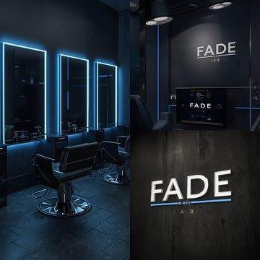
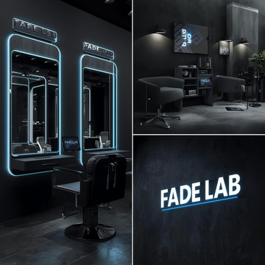
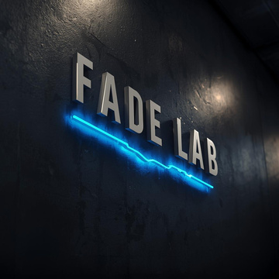
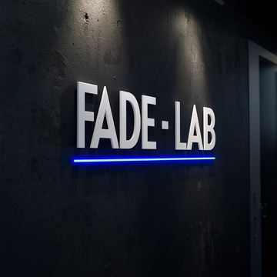
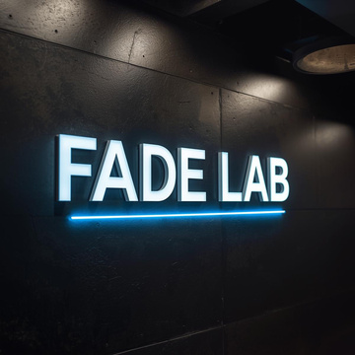
4️⃣ AI SMART SCREEN EXPERIENCE (CORE CONCEPT)
Prompt:
Ultra-realistic AI smart barber screen inside FADE LAB, large widescreen display showing AI haircut recommendations, face scan interface, blue tech UI on black background, modern touch interface, barber chair in front, HD camera mounted above screen, futuristic grooming technology, premium customer experience, realistic lighting, shallow depth of field, cinematic tech atmosphere
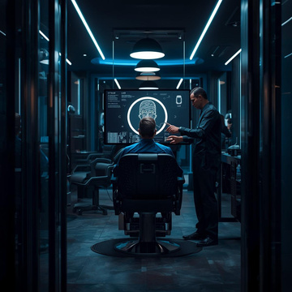
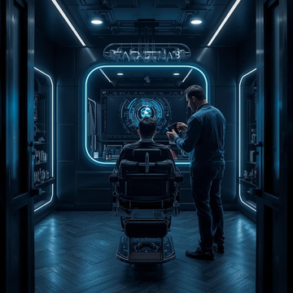
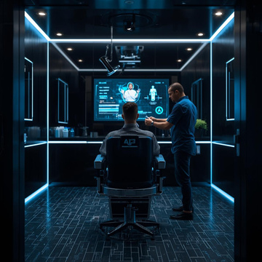
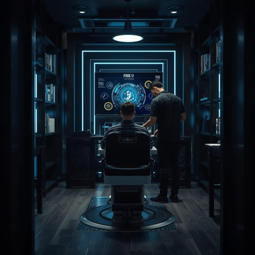
5️⃣ CUSTOMER EXPERIENCE SHOT (NO FACE VISIBLE)
Prompt:
Hyperrealistic barber shop experience inside FADE LAB, customer seated in premium barber chair facing AI screen, modern black and blue interior, professional barber standing beside, no visible faces, focus on environment and technology, luxury grooming experience, cinematic lighting, shallow depth of field, ultra-realistic photography style
6️⃣ BEFORE / AFTER CONTENT CREATION ZONE
Prompt:
Professional barber content creation setup inside FADE LAB, before and after photo capture area, HD camera on tripod, clean black background, electric blue accent lights, minimal barber tools, premium grooming studio vibe, social media content focused environment, ultra-realistic studio photography, sharp details
7️⃣ SOCIAL MEDIA REEL BRAND LOOK
Prompt:
Hyperrealistic social media reel preview for FADE LAB, vertical video frame style, before and after haircut comparison, dark background, electric blue graphic lines, minimal text overlay, FADE LAB logo watermark, premium barber branding, cinematic lighting, modern Instagram reel aesthetic, ultra-high quality
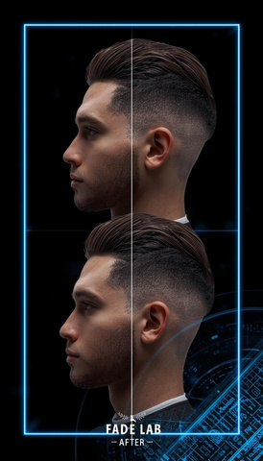
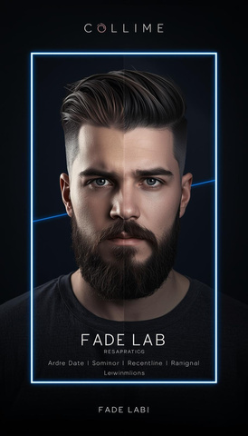
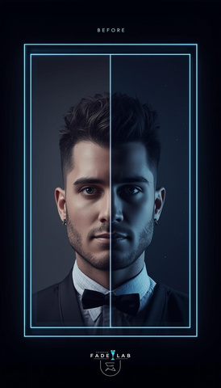
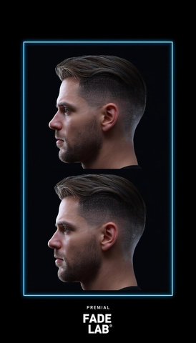
8️⃣ FREELANCER BARBER WORKSPACE (LAB CONCEPT)
Prompt:
Modern freelancer barber workstation inside FADE LAB, clean minimalist setup, black barber chair, professional tools neatly arranged, digital screen showing barber portfolio, premium lab-style grooming environment, masculine design, electric blue highlights, hyperrealistic interior photography
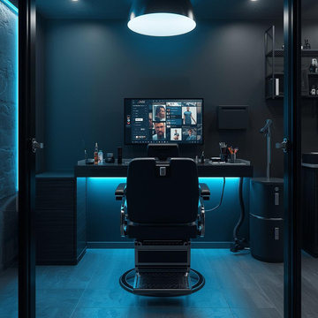
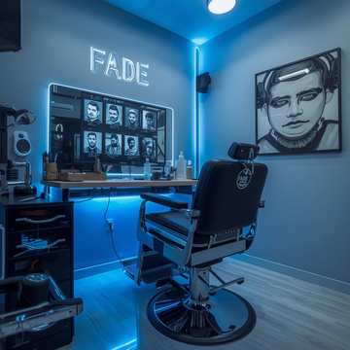
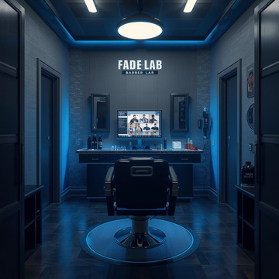
9️⃣ FADE LAB WEBSITE / DIGITAL BRAND MOCKUP
Prompt:
Premium website and digital brand mockup for FADE LAB, dark UI theme, black background, electric blue accents, modern typography, barber portfolio visuals, AI haircut technology showcase, luxury grooming brand website, clean layout, tech startup aesthetic, ultra-realistic screen mockup
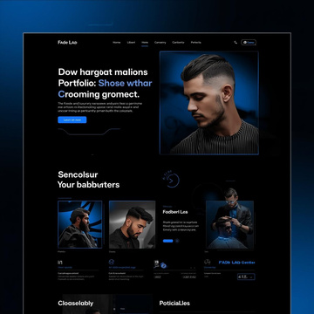
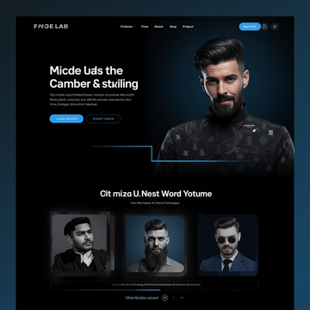
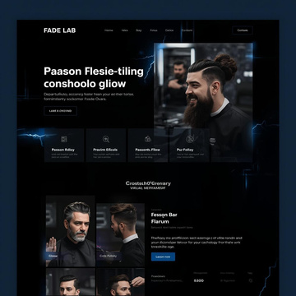
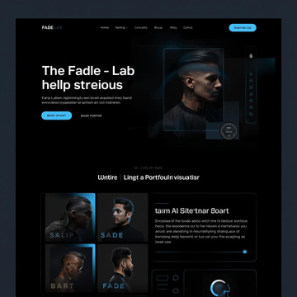
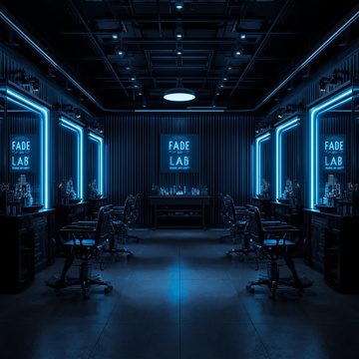
🔟 ULTIMATE BRAND EXPERIENCE (INVESTOR SHOT)
Prompt:
Cinematic ultra-hyperrealistic scene of FADE LAB barber shop as a complete brand experience, luxury modern grooming space, AI screens, premium lighting, minimal industrial design, black and electric blue color scheme, futuristic yet welcoming atmosphere, high-end commercial photography style, 8K realism, brand dominance feel

